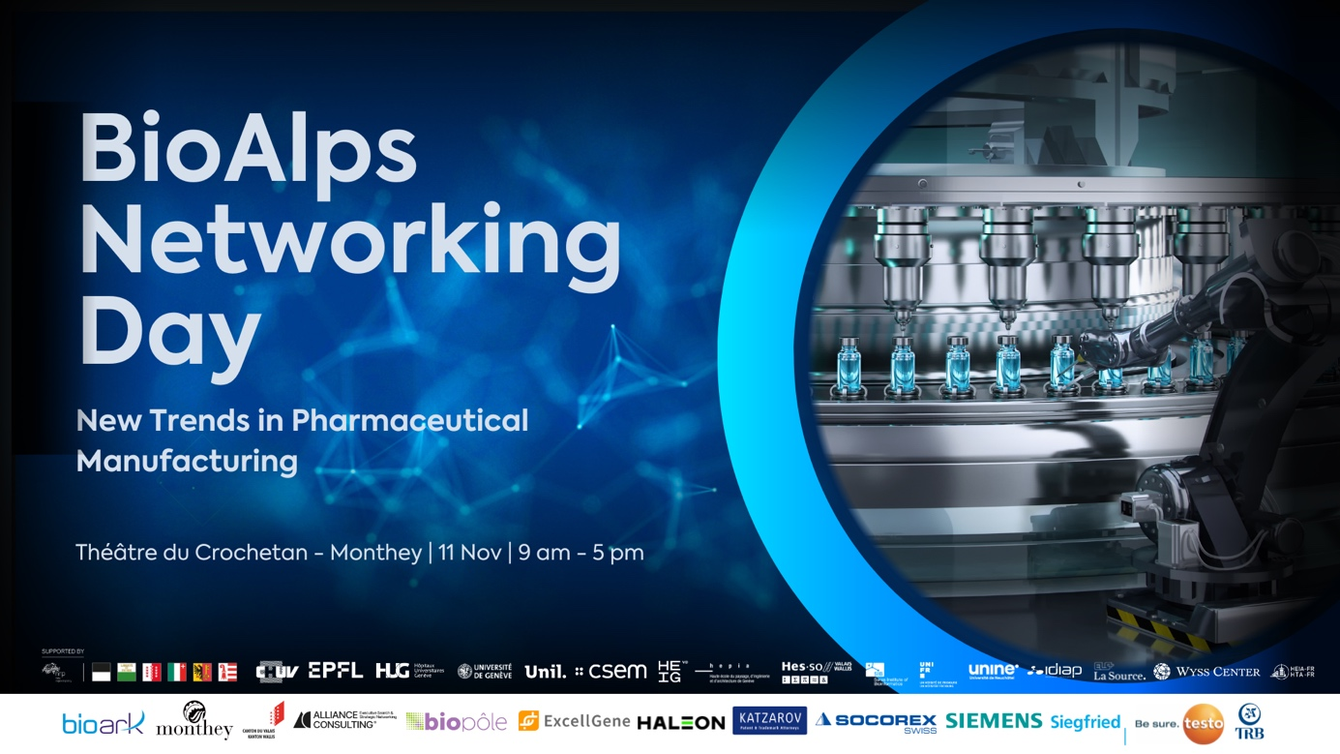
BioAlps Networking Day 2025
Programme

“New Trends in Pharmaceutical Manufacturing”
11 November 2025 | Theâtre du Crochetan | Monthey

INTRODUCTION TO VALAIS’ LIFE SCIENCES INNOVATION ECOSYSTEM

9.00 am BADGE COLLECTION
9.15 am WELCOME ADDRESS
Prof. Antoine Geissbühler | President | BioAlps Association
Mr. Jean-Marc Tornare | Managing Director | BioArk Monthey

9.30 am PRESENTATIONS FROM THE STARTUP INNOVATION ECOSYSTEM
BioArk
Mr. Paul-André Vogel | Managing Director | BioArk Visp
Ninsun Biotech
Dr. Sylvain Gnaho | Chairman
ImmunSkills
Mr. Adolfo Gonzalez | CEO & Founder
Ibex Therapeutics
Dr. Pierre A. Morgon | Co-founder & CEO
Stämm Vegh (VS)
9.45 am PRESENTATIONS FROM THE ACADEMIC INNOVATION ECOSYSTEM

Moderation by Prof Antoine Geissbühler
HES-SO Valais-Wallis
Prof. Nils Hanik | Professor UAS | HES-SO Valais-Wallis
HES-SO Valais-Wallis
Prof. Marc Pfeifer | Professor UAS |
Idiap Research Institute
Dr. André Freitas | Research Group Leader
CRR SUVA & EPFL
Prof. Friedhelm Hummel | Full Professor | EPFL
Dr. Bertrand Léger | Head of Research at Suva Clinics | CRR SUVA

10.30 am NETWORKING BREAK

11.00 am PRESENTATION OF S.M.A.R.T CONFLUENCE
Mr. Sébastien Mabillard | CimArk | Digital Health Initiatives

11.10 am PRESENTATION OF THE INDUSTRY INNOVATION ECOSYSTEM
Regen Lab
ExcellGene

11.50 am BIOALPS AWARDS CEREMONY

NEW TRENDS IN PHARMACEUTICAL MANUFACTURING

12.15 pm NETWORKING LUNCH AND EXHIBITION
1.30 pm AFTERNOON OPENING REMARKS
Prof. Antoine Geissbuhler | President | BioAlps Association
Mr. Christophe Darbellay | State Councillor for the Economy and Education | Canton of Valais
Mr. Fabrice Thétaz | President | Ville de Monthey

1.45 pm KEYNOTE
Moderation by Prof. Yogeshvar N. Kalia
Merck
Dr. Jonathan Souquet | Vice President, Head of Global Drug Substance Development

2.15 pm SESSION 1 | FROM LAB TO LINE: EMPOWERING HIGH-VALUE PHARMA & BIOTECH PRODUCTION

Moderation by Prof. Nicolas Mermod
Siegfried
Dr. Marcel Signer | Head of Production
Dr. Thomas Belser | Head of R&D and Pilot
Debiopharm Research & Manufacturing
Dr. Cédric Sager | CEO
Mr. Marco Salvagni | Executive Director of Operations
A series of presentations by leading actors, followed by an interactive roundtable.

3.00 pm NETWORKING BREAK

3.45 pm SESSION 2 | NEW TRENDS IN PHARMA & BIOTECH
Moderation by Dr. Carmen Jungo Rheme
Transforming the lab paradigm
Dr. Loïc Roch | CEO & Co-founder | Atinary Technologies
Mr. Bernd Gleixner | Division President Automation | Bruker
Transforming the manufacturing paradigm
Mr. François Carruzzo | Co-founder & CTO | Bioscibex
Dr. Florence Pojer | Head of Unit, Protein Production and Structure Core Facility | EPFL
Presentations highlighting the new trends in pharma and biotech, followed by conversations

4.45 PM SESSION 3 | SMART SCIENCE, SMARTER MANUFACTURING
Moderation by Mr. Federico Sasso
Siemens
Mr. Vincent Meyer | Head of Life Sciences
Ceidos (VS)
Mr. Sébastien Walpen | CEO
Plair (GE)
Dr. Svetlana Kiseleva | CPO & Co-founder

A series of presentation highlighting the Swiss Health Valley’s innovations.
5.15 pm NETWORKING AND DINNER COCKTAIL

